**Title: Use of Inbuilt functions and relational algebra operation**

**Objective:** To understand the use of inbuilt function and relational algebra with sql query.

1. **Create the following two tables (EMP and DEPT)**

I/O- select * from emp;

Select * from dept;

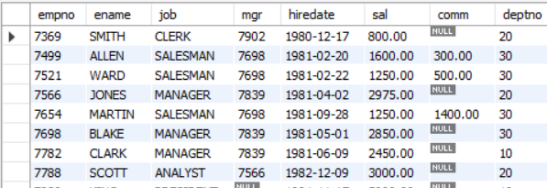

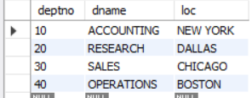

Write the Queries for the following using In-built functions.

1. Retrieve average salary of all employees.

I/O-Select avg(sal) from emp;



1. Retrieve the number of employees.

I/O- select count(ename) from emp;

1. Retrieve distinct number of employee.

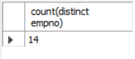I/O- select count(distinct empno) from emp;

1. Retrieve total salary of employee group by job.

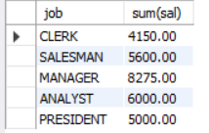select job,sum(sal) from emp group by job;

1. Display the employee information with maximum salary.

Select * from emp where sal=(select max(sal) from emp);



1. Find the highest paid employee in department 10.

select * from emp where (sal = (select max(sal) from emp)) and deptno=10;



1. List the emps whose sal is equal to the average of max and minimum.

Select * from emp where sal=(select (max(sal)+min(sal))/2 from emp);



1. List the emps who joined in the company on the same date.

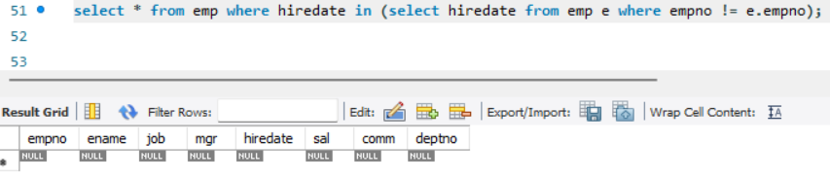

1. Display the employee names in upper and lower case.

Select Upper(ename),lower(ename) from emp;

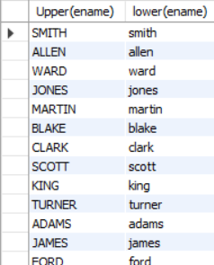

1. find the date of 3 days later from hiredate.

Select empno, adddate(hiredate,interval +3 day) from emp;

